“Online Art Gallery”

**SUBMITED BY**

PRITHVIRAJ DESHMUKH



## Department Of Computer Application.

**K.K.Wagh Arts, Commerce, Science and Computer Science College.**

## Nashik-422003

## Academic Year 2021-22



Karmaveer Kakasaheb Wagh Education Society’s

## K. K. Wagh Arts Commerce, Science, & Computer Science College Saraswati Nagar Nashik-422003

**C E R T I F I C A T E**

# This is to certify that,

**Mr**. **Prithviraj Deshmukh** has satisfactorily completed his project

**Online Art Gallery**  as fulfillment in **T.Y.B.B.A.(Computer Application)** Class for the academic year **2021-2022**.

# Project Done by: Prithviraj Deshmukh

Prof. Deepika Sonawane Prof. V.H. Bava

Project Guide (H.O.D)

Internal Examiner External Examiner

|  |  |  |
| --- | --- | --- |
| **Sr. No** | **Documentation Content** | **Page No** |
| **I** | **Introduction** | |
| 1 | Motivation | 4 |
| 2 | Problem Statement | 5 |
| 3 | Purpose / Objective and Goals | 5 |
| 4 | Literature Survey | 6 |
| **II** | **System analysis** | |
| 1 | Existing Systems | 7 |
| 2 | Scope and Limitations of Existing Systems | 7 |
| 3 | Project Perspective , Features | 8 |
| 4 | Requirement Analysis - Functional requirements, Performance requirements, Security requirements | 9 |
| **III** | **System Design** | |
| 1 | Class Diagram | 10 |
| 2 | Use Case ,Activity Diagram , Sequence Diagram,  Deployment Diagram | 11 |
| 3 | User Interfaces | 16 |
| **IV** | **Implementation details** | |
| 1 | Software / Hardware Specifications | 18 |
| **V** | **Outputs and Reports Testing** | |
| 1 | Screenshot and Report | 19 |

**Index - Website Project**

**Motivation**

We own our sincere gratitude to all those people who have given us their constant support and encouragement without which our project report would not have reached this stage.

We would like to express our thanks to Prof V.H Bava for her advice and encouragement. She has been a pillar of strength right through the project till the preparation of this report and helped by boosting morale, so we could surmount the difficulties that came across during completion of this project.

We would like to express our gratitude to Dr.A.P.Rajput, Principal, K.K.Wagh Arts, commerce, science and Computer Science College and Prof.Vijayshri Bava, Head of Computer Application department for the support and the infrastructure they have provided, so that we could successfully complete the project on time.

Last but not the least, we would like to express our sincere thanks to all staff members and our friends for their help and cooperation in all phases of the project.

1. Prithviraj Deshmukh

**Problem Statement**

Today it is becoming very difficult to maintain records manually. Now a day’s people are so busy to go to stores and buy the Arts they want. The hussle of moving from one Artstore to the other and not finding the arts you need is frustrating and time or resource consuming. In a Artstore we have deal with a large crowd. Then storekeeper has to maintain it with documents which are recorded by him. Therefore, there may be defective reports.

**Objective and Goals**

The main objective of the project is to create an online Art store that allows users to search and purchase a Art online based on their choice, artists and the dimensions. Using this website the user can purchase a art online instead of going out to a art store and can save time and money.

The system focuses precisely on the following goals :

1. To provide great discount over purchasing.
2. To provide wide range of collection of arts at one place.
3. To avail the information immediately in demand.
4. To manage the details about Arts, Bills, Customer.
5. To reduce manual work.

**Literature Survey**

A software developer company states that an e-commerce provides valuable information to the prospective customers about product specifications. Electronic Commerce applications support the interaction between different parties involved in an e-commerce transaction via the network, as well as the management of the data involved in the process.

Over three quarters of the 10,000 respondents report having purchased item through internet. The most mentioned reason for using the web for personal shopping was

1.Convenience(68%)

2.Followed by availability of vendor information (60%)

3.No pressure from sales person (55%)

4.Saving time (53%).

As the faith in security of e-commerce is increasing. More people has gained confidence in current encryption technologies, and users can be expected to frequently purchase items online. The interactive cycle between a user and a web site is not complete until the web site responds to a command entered by the user.

As per survey a good E-Commerce Site should present the factors such as minimal and strong security notifications or messages, effective categorical organization of products, simple navigation from home page to information and order links for specific products, consistent layout of product information to the customers for better usability.

**Existing System**

In existing scenario, people have to physically visit the artstores or artists for purchasing arts of their need and have to make payment through cash mode most of the times due to unawareness of advanced technologies at certain places.

In this method time as well as physical work is required, among which time is something that no one has an ample amount. The traditional art purchasing procedure is not efficient enough for shopkeepers as well as for customers, as they have to deal with the crowd, at shops.

In this system, one need to go to store and ask storekeeper for a art and you will get the art only if it is available in the store. If the required art is not available then you have to move to another store, which is time consuming.

**Scope and Limitations**

1. Lack of security data.
2. More man power.
3. Time consuming.
4. Consumers large volume of pare work.
5. Needs manual calculations.
6. Offline stores are restricted by time.
7. Offline stores tend to change a lot more money for their art than online artstores.

**Project Perspective**

This project is a website that acts as a central art store. This project is developed using php, css and javascript as the front end and Mysql as a back end. The Mysql database stores various art related details. A user visiting the website can see a wide range of arts. The user may select desired art and view its price. The user may even search for specific art on the website.

As the project is a web-based, multiple users can use it i.e the administrator, registered user and guest.

**Features**

1. Product and Component based
2. Creating and Changing issues at ease
3. It contain better storage capacity
4. Easy and fast retrieval of information
5. Well designed reports
6. Decrease the load of the person involve in existing manual system
7. Easy to update information
8. Simple user interface

**Requirement Analysis**

1. **Functional Requirement**

The user have to register first by filling the information asked in login form. The user can also sign in, he/she is already a registered user. After signing in user can search for a art and will have to click on buy now button to buy that art.

User can buy one art at a time. Users can also view their orders in order section.

Administrator will have to login to perform any function. Admin will be able to add/ delete/update arts and information as required. Admin can also manage the orders of users.

1. **Performance Requirement**

The interfaces of this Online Art Store system are to be simplified and made flexible. This system provides adequate usability and meets client’s requirement.

For instance, it does not take more than 10 seconds to match the inserted username and password. A user obtains result in 5 to 10 seconds after selecting the features and preferences. This system do not require too much equipment, and can be easily accessed from a laptop, a desktop computer or any device with an internet connection.

1. **Security Requirements**

All users are be properly authenticated before allowed entry into the system authentication will be based on an username and a password. All activities on the system are logged. This system protects the user account. When a user inserts an incorrect username or password while signing in, the system displays an error message.

Class Diagram

|  |
| --- |
| User |
| - user_id : int  - username : string  - email : string |
| + register( )  + login( ) |

|  |
| --- |
| Admin |
| - a_id : int  - name : string  - username : string  - email : string |
| + manage_arts( )  + manage_artists( )  + manage_orders( ) |

|  |
| --- |
| Customer |
| - c_id : int  - fullname : string  - address : string  - contact : string  - email : string |
| + buy_art( )  + remove( )  + add-details( )  + payment( ) |

**1..\***

1

|  |
| --- |
| Arts |
| - art_id : int  - image : string  - name : string  - artists : string  - price : string  - technique : string  - dimensions : string |
| + add_arts( )  + remove_arts( )  + update_arts( ) |

1..*

|  |
| --- |
| Artists |
| - artist_id : int  - image : string  - name : string  - description : string  - city : string |
| + add_artists( )  + remove_artists( )  + update_artists( ) |

1

1 0..*

|  |
| --- |
| Orders |
| - o_id : int  - artname : string  - price : string  - total : string  - status : string  - date : date  - payment : string |
| + add_details( )  + pay( ) |

**Use Case Diagram**

|  |
| --- |
| <<include>>    <<include>>  <<includes>>    <<includes>> |

Customer

Existing New

Admin

**Activity Diagram**

**User**

Login

Register

Check

Invalid

Valid

Select Arts

Remove

Buy Now

Fill Billing Address

Pay

Logout

**Admin**

Login

Check

Invalid

Valid

Manage Orders

Manage Artists

Manage Arts

Manage Admins

Logout

**Sequence Diagram**

System

Buy Now

Customer

1. Register

2. Login

3. Authentication

4. Select Art

5. Buy Now

6. Fill Billing

Address

7. Pay

8. Order Placed

9. My Orders

10. View Order

11. Logout

**Deployment Diagram**

Database Server

Client

LAN

Private Network

Web Server

Client

Private Network

Private Network

Client

**User Interface**

Arts Page :

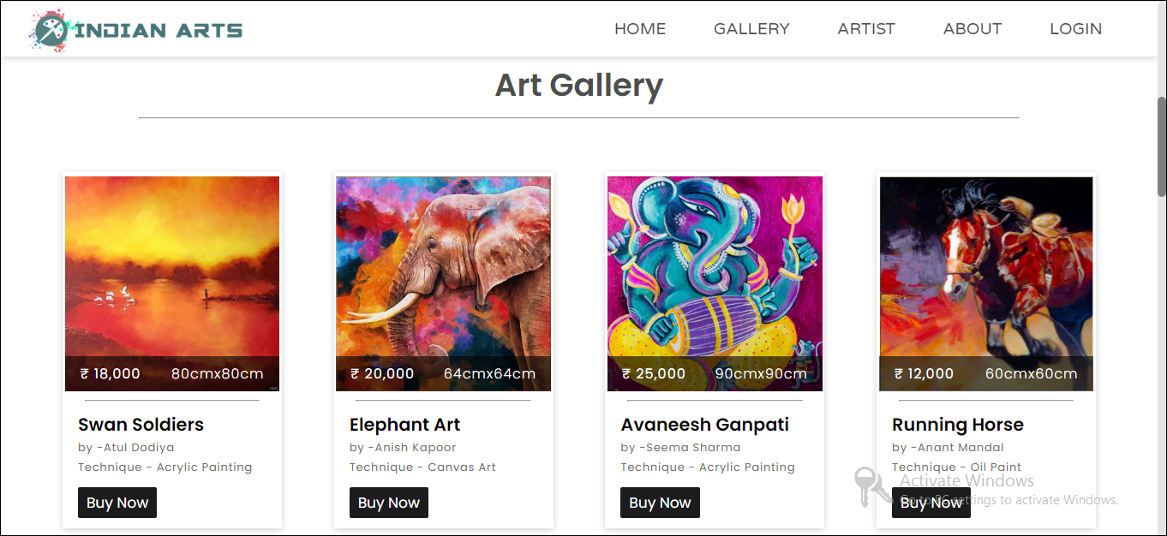

Artist Page :



View Order :

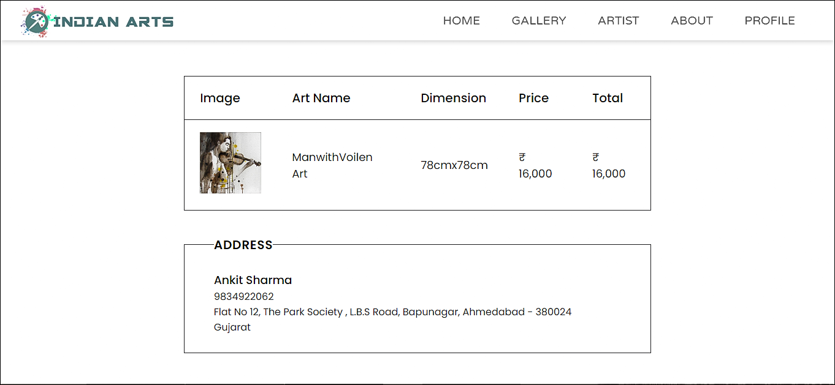

Buy Now Page :

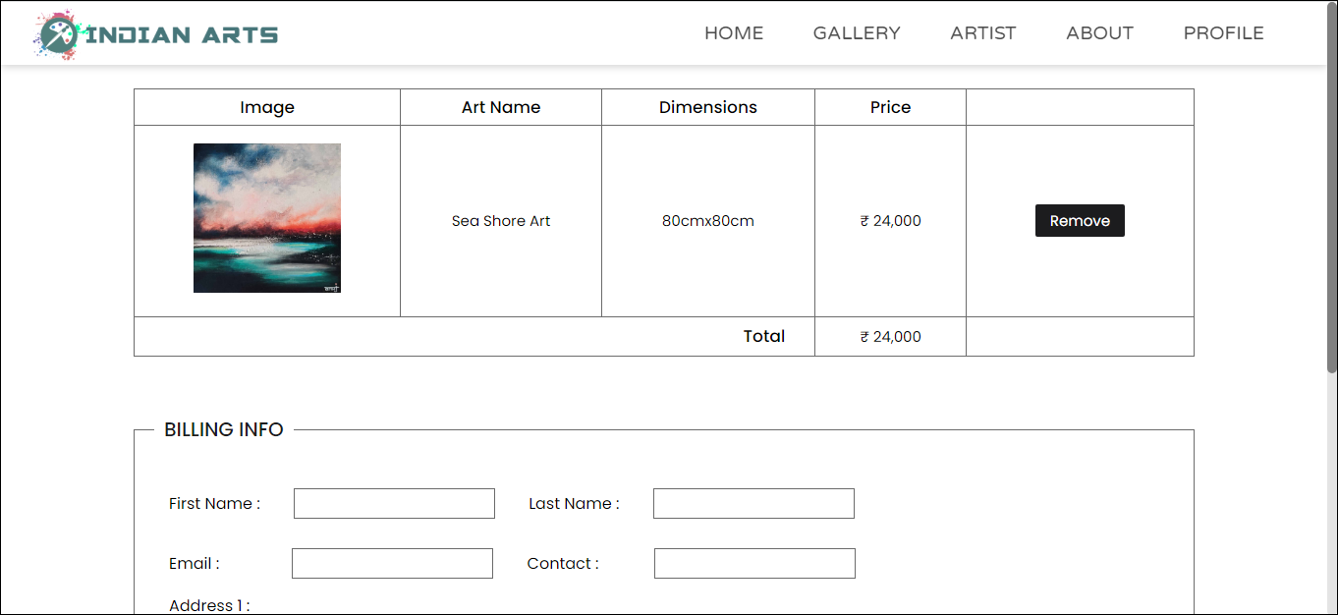

**Software / Hardware Specifications**

**1. Hardware Requirements :**

Processor : Intel core i3 or above

Speed : 2.30 GHz

Hard Disk : 500 GB or above

Memory : 2GB RAM or above

**2. Software Requirements :**

Operating : Windows 7/8/10

System

Front End : HTML, CSS, Javascript

Back End : PHP, MySql

Technology : XAMPP Server

**Screenshots and Reports**

**Screenshots :**

Add Arts(Admin) :

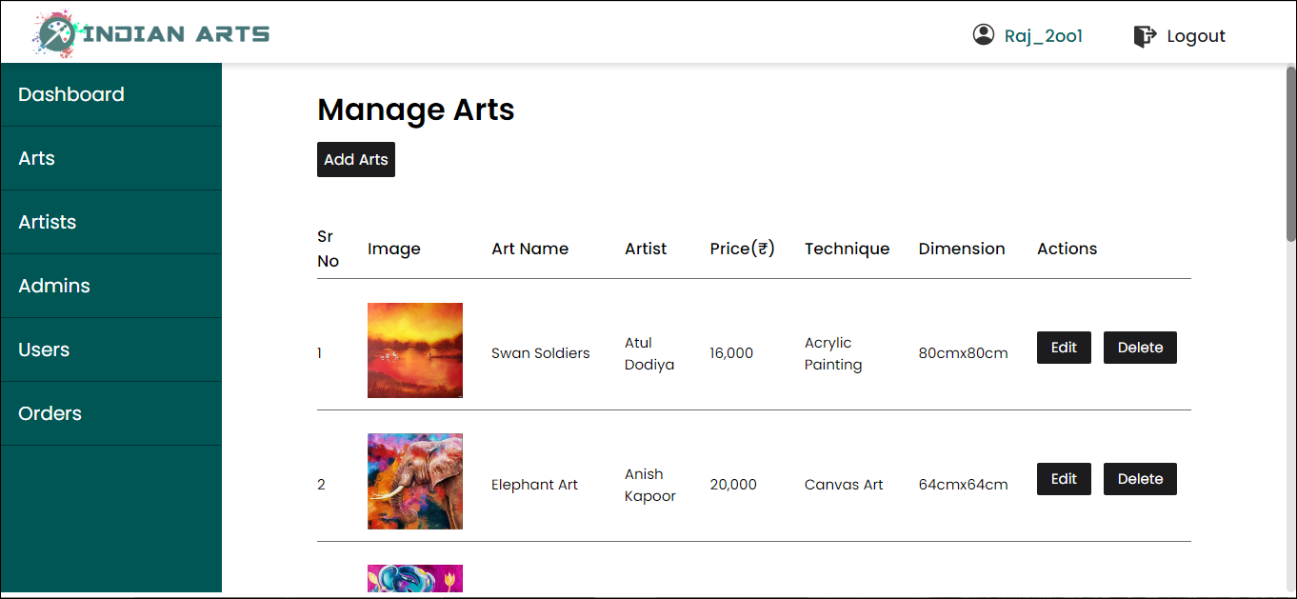

**Reports :**

Dashboard

